EX:No.6 221501060

05/04/25

**Implement program to apply moving average smoothing for data preparation and time series forecasting.**

**Aim:**

To Implement program to apply moving average smoothing for data preparation and time series forecasting**.**

**Algorithm:**

1. **Load the Data**:
   * Read the CSV file containing the weather data.
   * Parse the date column as a datetime index.
2. **Clean the Data**:
   * Handle missing values by performing forward and backward filling.
   * Drop any remaining NaN values.
3. **Normalize the Data**:
   * Apply **Min-Max Scaling** to normalize each column's values between 0 and 1.
4. **Add Time-Based Features**:
   * Extract additional features from the datetime index: day, month and year
5. **Visualize the Data**:
   * Plot the time series for a specific column (e.g., temperature T) over time.
6. **Execute the Program**:
   * Sequentially call the functions to load, clean, normalize, add features, and visualize the data.

**Code:**

import pandas as pd

import numpy as np

import matplotlib.pyplot as plt

date_range = pd.date_range(start='2025-01-01', periods=100, freq='H')

energy_consumption = np.random.normal(loc=150, scale=10, size=len(date_range

df = pd.DataFrame({

'Timestamp': date_range,

'Energy_Consumption': energy_consumption

})

df.set_index('Timestamp', inplace=True)

plt.figure(figsize=(12, 4))

plt.plot(df['Energy_Consumption'], label='Original Energy Consumption', alpha=0.5)

plt.title("Original Energy Consumption Data")

plt.xlabel("Time")

plt.ylabel("Energy (kWh)")

plt.legend()

plt.show()

window_size = 5 # you can change this depending on your data (e.g., 24 for daily average on hourly data)

df['Smoothed'] = df['Energy_Consumption'].rolling(window=window_size).mean()

plt.figure(figsize=(12, 4))

plt.plot(df['Energy_Consumption'], label='Original', alpha=0.4)

plt.plot(df['Smoothed'], label=f'{window_size}-Point Moving Average', color='red')

plt.title("Smoothed Energy Consumption Data")

plt.xlabel("Time")

plt.ylabel("Energy (kWh)")

plt.legend()

plt.show()

forecast_steps = 10

last_known = df['Smoothed'].dropna().iloc[-1]

forecast_index = pd.date_range(start=df.index[-1] + pd.Timedelta(hours=1), periods=forecast_steps, freq='H')

forecast_values = [last_known] * forecast_steps

forecast_df = pd.DataFrame({'Forecast': forecast_values}, index=forecast_index)

plt.figure(figsize=(12, 4))

plt.plot(df['Smoothed'], label='Smoothed Data')

plt.plot(forecast_df, label='Naive Forecast', linestyle='--', color='green')

plt.title("Naive Forecasting from Smoothed Energy Data")

plt.xlabel("Time")

plt.ylabel("Energy (kWh)")

plt.legend()

plt.show()

**Output:**

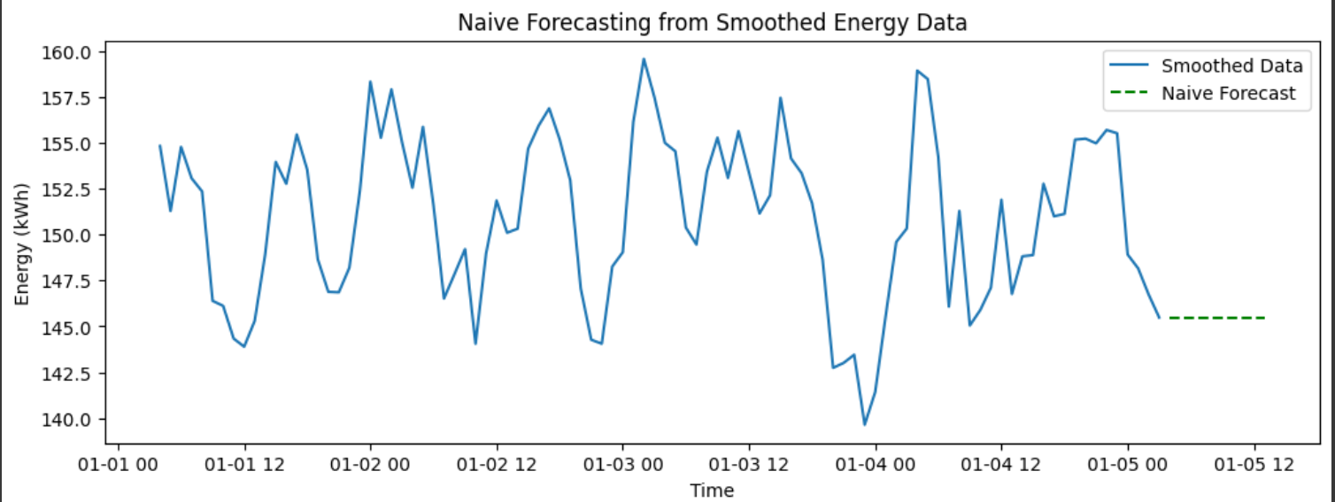

**Result:**

Thus, the program using the time series data implementation has been done successfully.